**Zonions Application**

**Summary :-**

It is a simple web application which is used to manage restaurants and view restaurants. It is build with technologies like React Js as frontEnd ,Sails Js as backEnd to create API'S and MongoDB as Database.

**Flow of the Application** :-

The Application contains two Models:

1.View model :- It is used to view the active restaurants and its details like address of restaurant, restaurants timings, menu's,etc.

2.Admin model :- It is used to manage every restaurant details .for ex: admin can add new restaurants and maintain list of active and deactivated restaurants , update and delete restaurants.

**Diagram Flow**:-

List of Restaurants

Admin Login

Manage Restaurants

View Restaurant

Edit

Add Restaurants

Delete

**Home Page**

**Rest Api's :-**

1. Add Restaurant :- POST /AddRestaurant

2.Get All Restaurants :- GET /GetRestaurants

3.Update Restaurant :- PUT /UpdateRestaurant/:id

4.Delete Restaurant :- DELETE /DeleteRestaurant/:id

**Screens :-**

**1. Home Page:-**

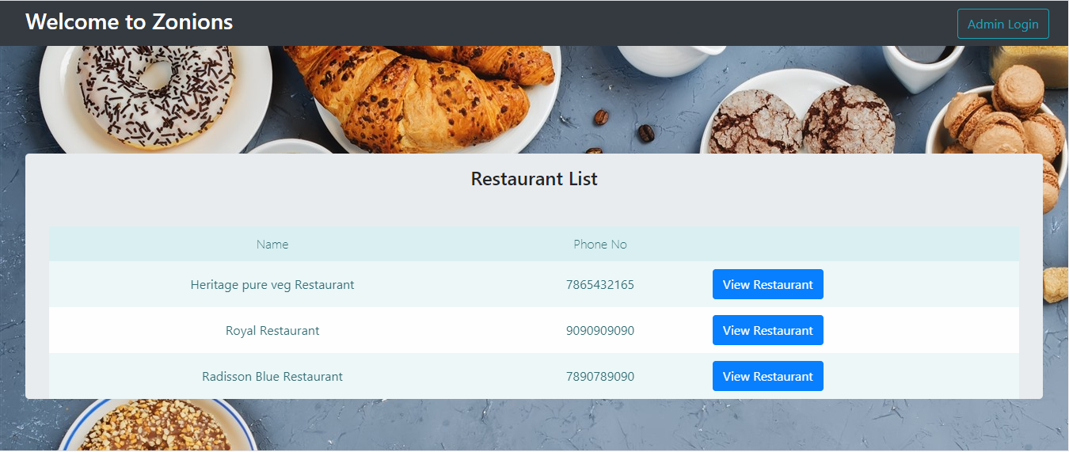

**2.View Restaurant**

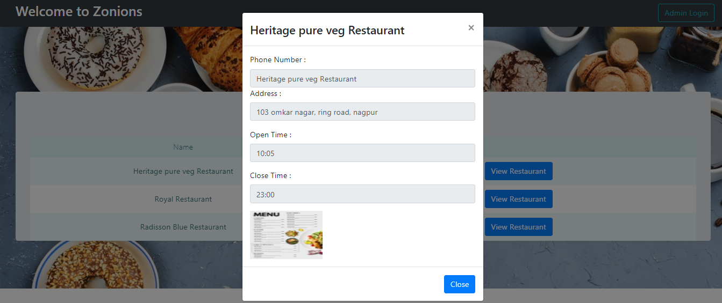

**3.Login Page**

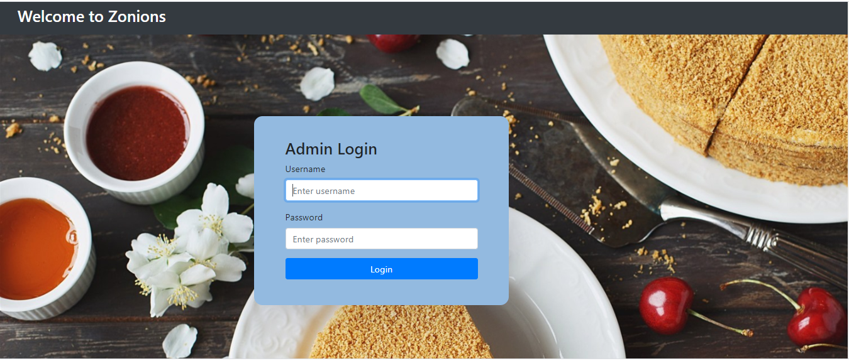

**4.Restaurant Management Page**

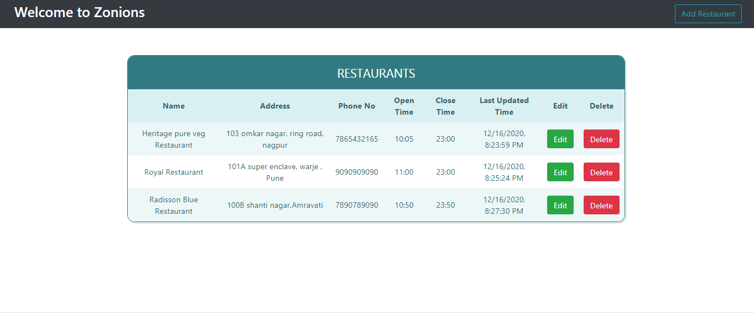

**5. Add Restaurant Page**

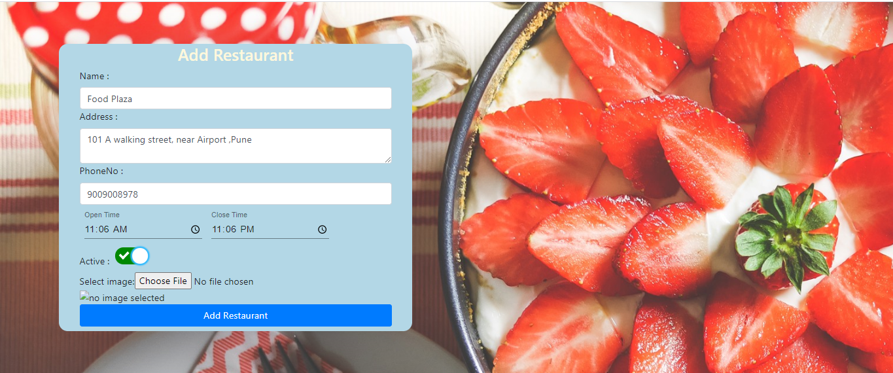

**6.Edit Restaurant**

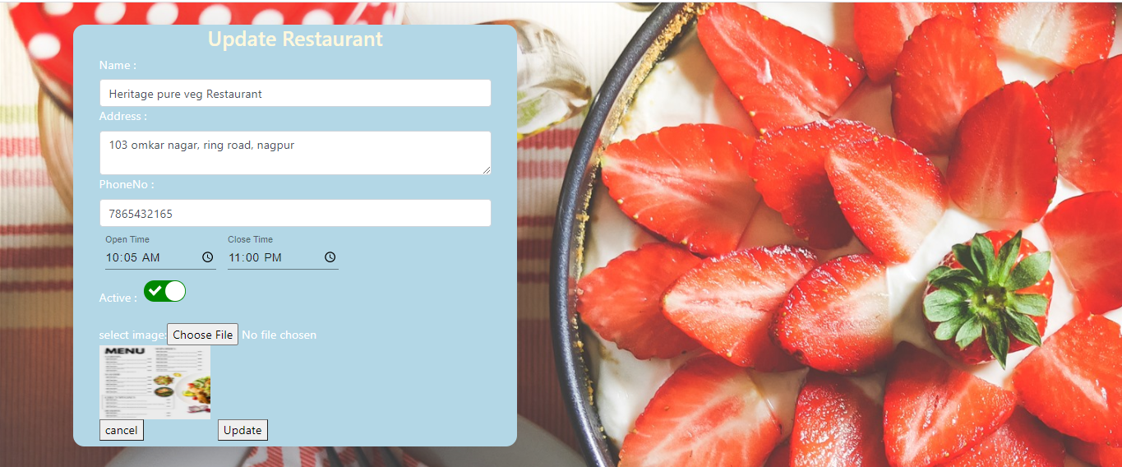

**!! Thank you !!**